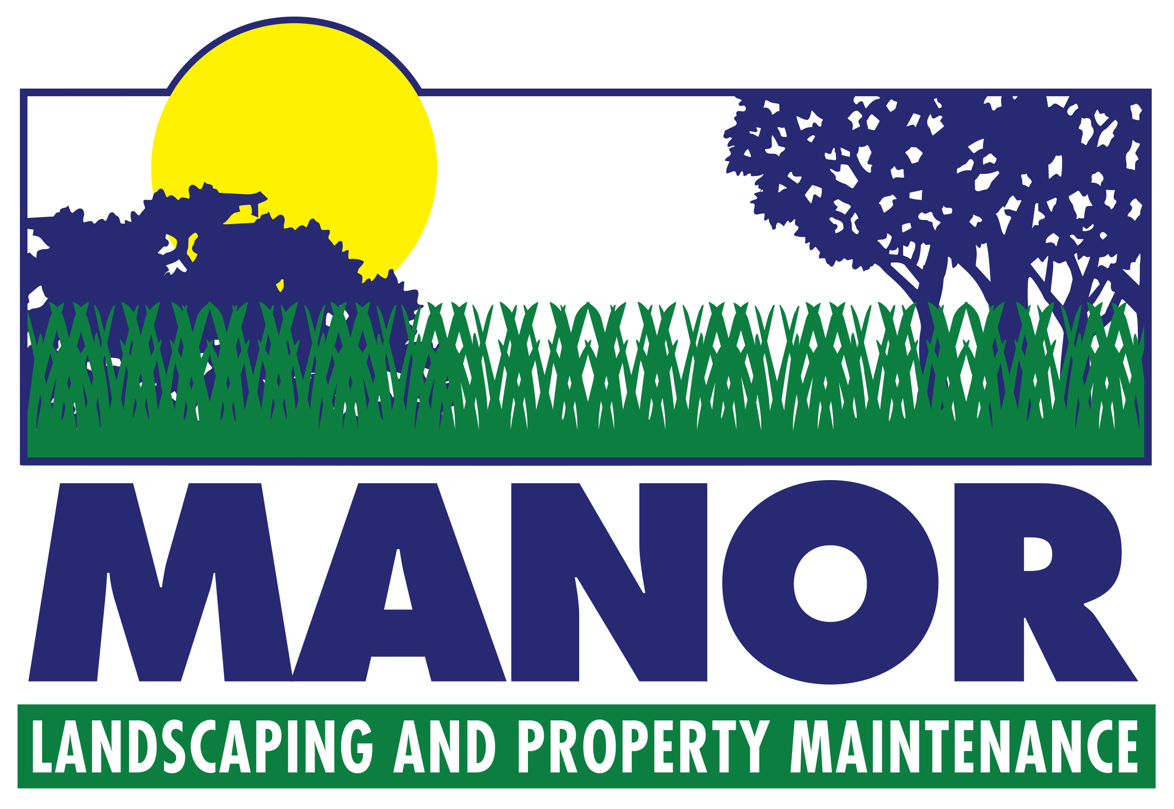
Manor Landscaping & Property Maintenance Inc. is pleased to provide an outline
for professional maintenance services for your Residential and or Commercial
Property throughout the 2016 season

#1 SPRING CLEAN UP – APRIL
- Clean up of entire grounds including collection & removal of all debris, lawn raking to remove sand, gravel & turf winterkill. Commencing in April and will be invoiced out at $50.75 / hour / man.
- De-thatching and Power Raking to remove excess thatch build-up and allow air and nutrients to the grass root system, therefore reducing the need for repair and restoration later in the season. As well this process will remove any sand or gravel that may have accumulated over the winter. Rate of service - $75.00/ treatment
- Removal of all accumulated debris
Your property will be left in an immaculate condition at the conclusion of the spring clean up.
- Early Spring Policy—in the event of an early spring whereby the lawn area requires cutting in the last week of April, a separate charge will be invoiced.

#2 LAWN MOWING, TRIMMING AND GARDEN MAINTENANCE
- All turf will be mowed on a weekly basis amounting to approximately 26 visits during the season.
- Maintenance service includes: power trimming along walls, curbs and fences, power edging along driveways and sidewalks and weekly maintenance, which will result in weed-free annual and evergreen gardens.

#3 LAWN FERTILIZING
- Manor Landscaping and Property Maintenance are happy to offer lawn fertilizing. We are dedicated to the minimum use of pesticide and providing proper fertilizing and cultural practices to maintain healthy, robust lawns.

#4 FALL CLEAN-UP: OCTOBER-NOVEMBER
- Includes removal and collection of leaves, annuals, perennial foliage, etc. as required. Shrubs are wrapped in burlap to be protected from salt spray and windburn.

